Client: Mike (C++, C#, .NET)

File/Directory Copier/Mover with Progress

**Details:**

The project requires the implementation of a user interface to facilitate the copying process. The interface should provide progress updates and allow users to specify the folder from which files and directories should be copied with the option to overwrite files or not. This project should use a Backgroundworker to complete Asynchronous function of copying process byte by byte with an option to hook into Windows Explorer using a previously used C++ Win32 API for the paste event so that my program gives the option to use Windows Explorer or my program to do the copying/moving operation similar to UltraCopier or TeraCopy. There is a library that can be used for the paste event handler that has already been created. This project also needs to record progress using a ProgressBar, calculate the total time left, the kb and mb per second of the copying process, the total file count, the files left to achieve the process, the filename and directory being worked on, and the file and directory totals to be copied with the total progress of operation on two separate ProgressBars. It must also have the ability to deal with large amounts of data for the copying process, while showing the list of files/directories to be copied and files/directories that have been copied and completed as the copying process is completed by using a DataGridView.

**Client chat:**

familiar with C# .Net WinForms

and C++ Win32 API

and porting C++ Win32 API into a C# WinForms project

I would need a File/Directory copier using an existing C++ Win32 API library to hook into the Windows Explorer paste event and give the option to use either Windows Explorer or my program to do the copying/moving process

<https://github.com/alphaonex86/Catchcopy>

That is the it is under the catchcopy-windows-explorer-plugin folder in that library

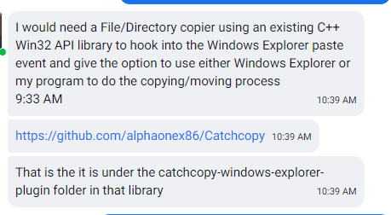

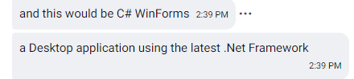

**Timeline 3 weeks**

Need update in **every 3 to 4 days**.

We will split the complete project into **5 milestones**